Supplemental Figures:
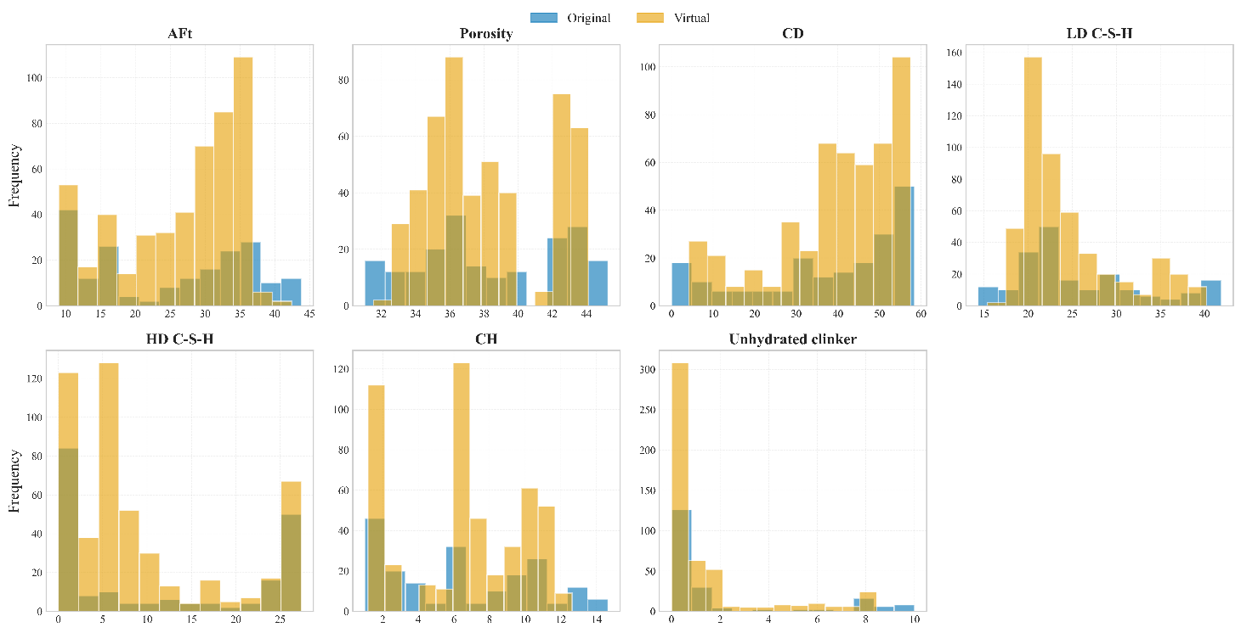
Fig. S1. Feature distribution comparison between original and virtual samples.
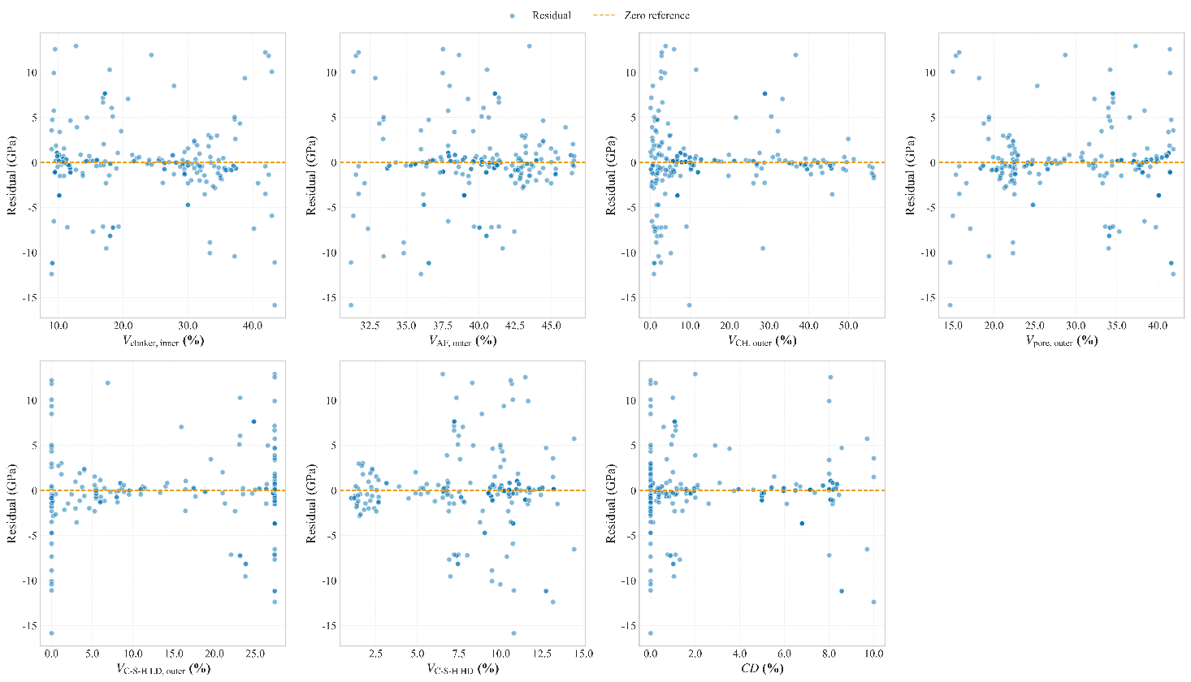
Fig. S2. Residuals versus predicted values for PIRL‑EU.

